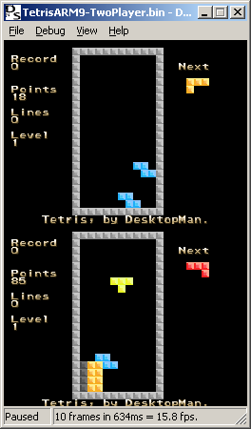
DSemu is an emulator written by Imran Nazar, and will eventually emulate a Nintendo DS on many platforms. Currently, since very little information about the DS is on public release, this is a Gameboy Advance emulator for Windows.

